Procure to Pay Return Flow

Understanding Vendor Returns, Credits, Inventory Reversal, Accounts Payable Adjustments & Financial Impact

Accounts PAYABLE Adjustments & Financial Impact
Weekly Learning Series – Week 13

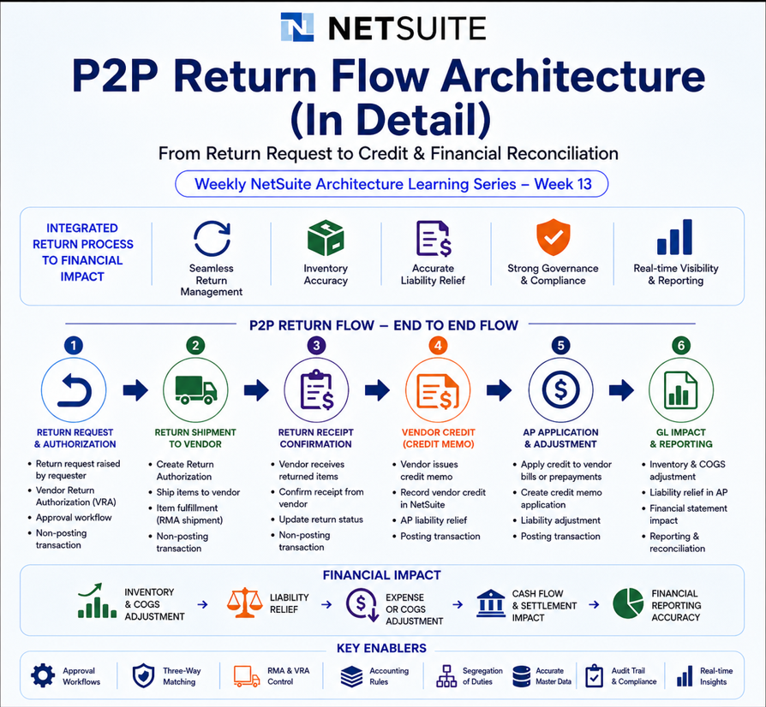

1. Introduction
The Procure-to-Pay (P2P) Return Flow in NetSuite governs how organizations return goods back to vendors after procurement has already occurred.
This lifecycle manages inventory reversals, vendor credits, liability adjustments, and financial reconciliation.
The return lifecycle becomes necessary when organizations encounter situations such as:
- damaged inventory received from vendors,
- incorrect item shipments,
- quality failures during inspection,
- over-delivery of items,
- pricing disputes,
- or warranty replacement scenarios.
Unlike the forward Procure-to-Pay flow, return architecture reverses inventory ownership and financial liability. Humans spend millions implementing procurement systems and then immediately need another system explaining how to undo procurement. Civilization remains consistent.

2. P2P Return Architecture
Vendor Return Authorization (VRA) is a non-posting transaction used to track returns back to vendors. The complete vendor return process generally includes four stages:
- Vendor Return Authorization
- Approval / Return Validation
- Item Fulfillment (Shipment to Vendor)
- Vendor Credit or Refund
The Vendor Return Authorization feature must be enabled under,
Setup > Company > Enable Features.

3. End-to-End Vendor Return Lifecycle
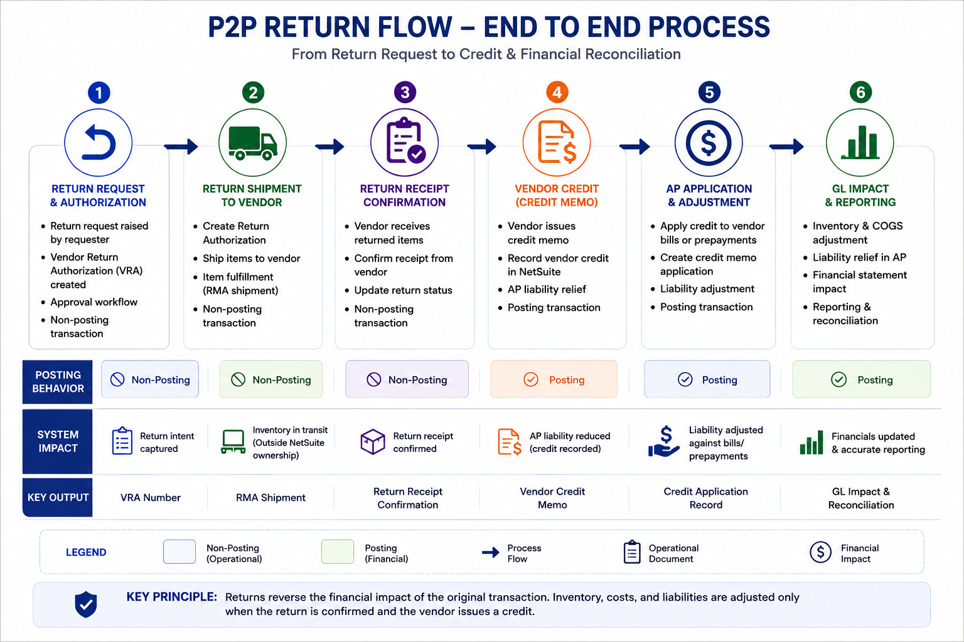

Stage 1 — Identify Return Requirement
- Damaged inventory discovered during receiving
- Quality inspection failure
- Incorrect vendor shipment
- Excess quantity delivered
- Procurement cancellation after receipt

Stage 2 — Create Vendor Return Authorization (VRA)
- Non-posting transaction
- Tracks return intent
- Links returned items to original procurement
- Captures quantities, reasons, and vendor references
- Supports approval workflows

Stage 3 — Approve Vendor Return
- Manager or procurement approval
- Validation against original PO and receipt
- Segregation-of-duty enforcement
- Fraud prevention controls

Stage 4 — Ship Items Back to Vendor
- Inventory leaves organizational ownership
- Item Fulfillment transaction generated
- Inventory asset reduced
- Temporary return accrual may be created

Stage 5 — Receive Vendor Credit
- Vendor issues refund or credit memo
- Accounts Payable liability adjusted
- Return accrual cleared
- Financial reconciliation completed

4. Vendor Return Authorization (VRA)
Vendor Return Authorization is the foundational control document for the return process.
Behavior | Description
Posting Behavior | Non-posting
Purpose | Tracks vendor return intent
Inventory Impact | None during authorization
GL Impact | No GL posting
Approval Support | Yes
Vendor Linkage | Can originate from PO or Vendor Bill

The Vendor Return Authorization may be created directly(Standalone) or from an existing Purchase Order.

5. GL Impact Across Return Lifecycle
Financial impact in return architecture occurs only when inventory ownership changes or vendor liabilities are adjusted.
Transaction | Posting? | Typical Impact
Vendor Return Authorization | No | No GL impact
Item Fulfillment / Return Shipment | Yes | Inventory reduction
Vendor Credit | Yes | AP reduction
Vendor Refund | Yes | Cash increase / settlement

5.1 Inventory Return GL Impact
Typical accounting behavior during return shipment:
- Dr Accrued Vendor Returns
- Cr Inventory Asset
This reflects that inventory has physically left the organization but vendor credit may not yet be received.

5.2 Vendor Credit GL Impact
Typical Vendor Credit accounting:
- Dr Accounts Payable
- Cr Accrued Vendor Returns
This clears the temporary accrual created during the return shipment stage.

6. Approval Architecture & Internal Controls
- Return approvals based on financial thresholds
- Validation against original Purchase Orders
- Three-way return matching
- Duplicate return prevention
- Warehouse verification before shipment
- Segregation of duties between warehouse, AP, and procurement teams
Because allowing one person to create vendors, receive inventory, authorize returns, and issue credits is how internal audit teams acquire job security.

7. Real-World Failure Scenarios

Scenario 1 — Vendor Credit Never Received
Inventory removed but vendor credit missing creates unreconciled accrual balances.

Scenario 2 — Duplicate Return Shipment
Same inventory returned twice due to poor warehouse controls.

Scenario 3 — Return Without Original PO Linkage
Audit trail weakens and procurement reconciliation becomes unreliable.

Scenario 4 — Closed Period Return Processing
Return transactions may fail or shift into incorrect accounting periods.

8. Advanced Architectural Considerations
- OneWorld subsidiary restrictions
- Multi-Book accounting behavior
- Serialized and lot-numbered item returns
- Drop-ship return processing
- Intercompany procurement returns
- Landed cost reversal handling
- Workflow-driven return approvals
- Vendor replacement vs vendor credit handling

9. Architect Insight
A Purchase Return is not merely an inventory reversal. It is a synchronized operational and financial correction process spanning procurement, warehouse management, accounts payable, and the general ledger.
The architecture exists to ensure that inventory exits, vendor credits, and financial liabilities remain aligned across reporting periods.

